**IDENTIFYING RECYCLABLE MATERIALS FROM IMAGES**

**A Project Report Submitted**

**In partial fulfillment of the requirements for the award of the degree of**

**Bachelor of Technology**

**in**

**Information Technology**

**by**

## P.NAVEEN REDDY 23N35A1214

## R.SRIHARI 23N35A1215

## T.SIDDHARTH REDDY 22N31A12H8

Under the esteemed guidance of

**Mr.M.SAI KRISHNA MURTHY**

**Assistant Professor**



**Department of Information Technology**

# Malla Reddy College of Engineering & Technology

**(Autonomous Institution- UGC, Govt. of India)**

(Affiliated to JNTUH, Hyderabad, Approved by AICTE, NBA &NAAC with ‘A’Grade)

Maisammaguda, Kompally, Dhulapally, Secunderabad – 500100 website: [www.mrcet.ac.in](http://www.mrcet.ac.in/)

**2025-2026**



# Malla Reddy College of Engineering & Technology

**(Autonomous Institution- UGC, Govt. of India)**

(Affiliated to JNTUH, Hyderabad, Approved by AICTE, NBA &NAAC with ‘A’ Grade)

Maisammaguda, Kompally, Dhulapally,Secunderabad – 500100 website: [www.mrcet.ac.in](http://www.mrcet.ac.in/)

## CERTIFICATE

This is to certify that this is the bonafide record of the Project entitled **“Identifying Recyclable Materials From Images”**, submitted by **P.Naveen Reddy (23N35A1214),R.SRIHARI (23N35A1215) and T.Siddharth Reddy (22N31A12H8)** of B.Tech in the partial fulfillment of the requirements for the degree of Bachelor of Technology inInformation Technology during the year 2025-2026. The results embodied in this project report have not been submitted to any other university or institute for the award of any degree or diploma.

**Internal Guide Head of the Department Mr.M.Sai Krishna Murthy Dr.G. Sharada**

**Assistant Professor Professor**

**External Examiner**

## DECLARATION

We hereby declare that the Project titled **“Identifying Recyclable Materials From Images”** submitted to Malla Reddy College of Engineering and Technology (UGC Autonomous), affiliated to Jawaharlal Nehru Technological University Hyderabad (JNTUH)for the award of the degree of Bachelor of Technology in Information Technology is a result of original work carried-out in this project .It is further declared that the project report or any part thereof has not been previously submitted to any University or Institute for the award of degree or diploma.

## P.NAVEEN REDDY 23N35A1214

## R.SRIHARI 23N35A1215

## T.SIDDHARTH REDDY 22N31A12H8

## ACKNOWLEDGEMENT

We feel honored to place our warm salutation to our college Malla Reddy College of Engineering and Technology (UGC-Autonomous) for giving us an opportunity to do this Project as part of our B.Tech Program. We are ever grateful to our Director Dr. VSK Reddy and Principal Dr.S.Srinivasa Rao who enabled us to have experience in engineering and gain profound technical knowledge.

We express our heartiest thanks to our HOD, Dr. G. Sharada for encouraging us in every aspect of our course and helping us realize our full potential.

We would like to thank our Project Guide Mr.M.Sai Krishna Murthy for his regular guidance, suggestions and constant encouragement. We would like to thank our Class Incharge Ms.M.Aishwarya who in spite of being busy with his/her academic duties took time to guide and keep us on the correct path.

We would also like to thank all the faculty members and supporting staff of the Department of IT and all other departments who have been helpful directly or indirectly in making our project a success.

We are extremely grateful to our parents for their blessings and prayers for the completion of our project that gave us strength to do our project.

With regards and gratitude

## P.NAVEEN REDDY 23N35A1214

## R.SRIHARI 23N35A1215

## T.SIDDHARTH REDDY 22N31A12H8

**ABSTRACT**

The increasing importance of waste management and recycling has driven the need for efficient and automated systems to identify recyclable materials. This study explores the application of computer vision and deep learning techniques to classify recyclable items from images. Using convolutional neural networks (CNNs) and transfer learning with pre-trained models such as ResNet, EfficientNet, or YOLO, we develop a system capable of distinguishing between different categories of recyclable waste, including paper, plastic, glass, and metal.

The proposed approach involves dataset collection, preprocessing, model training, and evaluation using metrics such as accuracy, precision, and recall. Experimental results demonstrate the effectiveness of deep learning in accurately identifying recyclable items, with potential applications in smart waste sorting systems, recycling facilities, and consumer-facing apps.

**TABLE OF CONTENTS**

|  |  |  |  |
| --- | --- | --- | --- |
| **Chapter No.** | | **Contents** | **Page No** |
| 1 |  | Introduction | 1 |
| 1.1 | Problem Definition |  |
| 1.2 | Existing and Proposed System |  |
| 2 |  | Literature Review | 2 |
| 3 |  | SRS(Software Requirements Specification) | 3-4 |
| 3.1 | Functional and Non Functional Requirements | 3 |
| 3.2 | Software and Hardware Requirements | 4 |
| 4 |  | System Design | 5-7 |
| 4.1 | Architecture of System | 5 |
| 4.2 | UML Diagrams | 6-7 |
| 5 |  | Methodology | 8 |
| 5.1 | Technologies Used |  |
| 5.2 | Algorithms/Techniques |  |
| 6 |  | Implementation | 9-13 |
| 6.1 | Sample Code | 9-11 |
| 6.2 | Output Screens | 12-13 |
| 7 |  | Testing | 14 |
| 7.1 | Testing Methods |  |
| 7.2 | Test Cases |  |
| 8 |  | Conclusion | 15 |
|  |  | Bibliography | 16 |

**INTRODUCTION**

* 1. **PROBLEM DEFINATION**

Every day, people throw away a lot of trash, and not all of it is sorted properly. Many items that could be recycled end up in the wrong bin, which causes problems for recycling centers. One reason this happens is because people often don’t know what can and can’t be recycled. This project aims to solve that problem by using computer technology to recognize recyclable items With the help of machine learning and image recognition, we can teach a computer to look at a picture of trash and decide if it can be recycled. This can make recycling easier, reduce waste, and help protect the environment. The increasing importance of waste management and recycling has driven the need for efficient and automated systems to identify recyclable materials.

* 1. **EXISTING AND PROPOSED SYSTEM**

## EXISTING SYSTEM

The identification and segregation of recyclable materials are mostly **manual**. Waste is sorted by workers who visually inspect items, which is **time-consuming**, **labor-intensive**, and **prone to human error**. Traditional methods rely on **barcode scanning or manual labeling**, which cannot handle **mixed waste** effectively. These approaches also **lack automation and scalability**, making them unsuitable for large-scale recycling operations. Additionally, there is **no intelligent system** capable of automatically identifying materials from images, limiting efficiency and accuracy in waste classification.

## PROPOSED SYSTEM

an **AI-based image classification model** that automatically identifies recyclable materials—such a **plastic, paper, glass, and metal**—from images. Using **Convolutional Neural Networks (CNNs)** and **transfer learning** with pre-trained models like **ResNet**, the system analyzes uploaded or captured images to determine whether an item is recyclable. The proposed approach includes such as Image collection and preprocessing (resizing, normalization, augmentation).Model training and evaluation using accuracy, precision, and recall metrics.Integration into a **user-friendly interface** for real-time image classification.This system automates waste identification, reduces manual effort, improves recycling accuracy, and promotes **smart and sustainable waste management**.

**1**

**LITERATURE REVIEW**

|  |  |  |  |  |
| --- | --- | --- | --- | --- |
| **Name of Author** | **Title of the paper** | **Methodology** | **Results** | **Future Enhancement** |
| Mei Wang, Wenping Deng | Identification of recyclable materials using image processing. | Developed custom CNN trained on labeled recyclable material images; included preprocessing and feature extraction. | Over 90% accuracy in distinguishing recyclables like metal, plastic, glass in mixed-waste scenarios. | Expand to more materials; real-time sorting optimization; detect contamination (e.g., food residues).. |
| Jiawei Chen, Rui Li, Xinyu Zhang | Multi-Class Image Classification Using Transfer Learning for Recycling Automation | Used transfer learning (MobileNet, EfficientNet) for classifying recycling images with limited data. | Achieved high accuracy with fewer training images; suitable for data-constrained recycling applications. | Improve handling of ambiguous/mixed waste; optimize for mobile/embedded devices; explore semi-supervised learning. |
| Ran Tian,  Zhihe Wang | AI-Powered Visual Recognition for Smart City Systems | Applied ML to detect urban elements (e.g., bins, waste) via city-wide camera networks; included edge deployment. | Robust detection under varying lighting/angles; practical for public recycling bin monitoring. | Improve extreme condition performance; support recyclability classification; hybrid edge-cloud deployment. |
| Raymond hong,  Wen Jie Zhao | Automated Product Tagging Using Deep Learning for Image-Based Recognition | Utilized deep CNNs (e.g., ResNet, VGG) for product image classification based on shape, color, and texture. | High accuracy in recognizing diverse and visually similar products; relevant for recyclable item detection. | Enhance performance in cluttered scenes; implement few-shot learning; integrate image and text data. |

**2**

**SOFTWARE REQUIREMENTS SPECIFICATION**

**3.1 FUNCTIONAL AND NON-FUNCTIONAL REQUIREMENTS**

**FUNCTIONAL REQUIREMENTS**

* Image Upload:

The system should allow users to upload or capture an image of a waste item.

* Image Preprocessing:

The system should preprocess the uploaded image to prepare it for classification.

* Classification:

The system should classify the image into categories such as plastic, metal, glass, paper using a

trained CNN model.

* Confidence Score:

The system must display a confidence percentage along with the classification result (e.g., 92%).

* Result Display:

The system should show the classification result clearly in the interface.

**NON FUNCTIONAL REQUIREMENTS**

* Accuracy:

The model should achieve high accuracy (e.g., above 85%) in classifying recyclable items.

* Latency:

The system should respond with classification results in under 2–3 seconds.

* Usability:

The interface should be simple and user-friendly, suitable for mobile and desktop.

* Scalability:

The system should be able to handle multiple requests simultaneously without crashing.

* Security:

The system must not store sensitive user data, and any uploaded image should be

securely handled.

**3**

**3.2 SOFTWARE AND HARDWARE REQUIREMENTS**

**SOFTWARE REQUIREMENTS**

* Operating System : Windows 11
* IDE : VS Code Studio
* Languages : Python 3.10
* Libraries : Pandas
* Database : Supabase

**HARDWARE REQUIREMENTS**

* Processor : Intel core i5
* Ram : 8 GB (16 GB Recommended)
* Hard disk   :  512 GB

**4**

**SYSTEM DESIGN**

**4.1 ARCHITECHTURE OF SYSTEM**

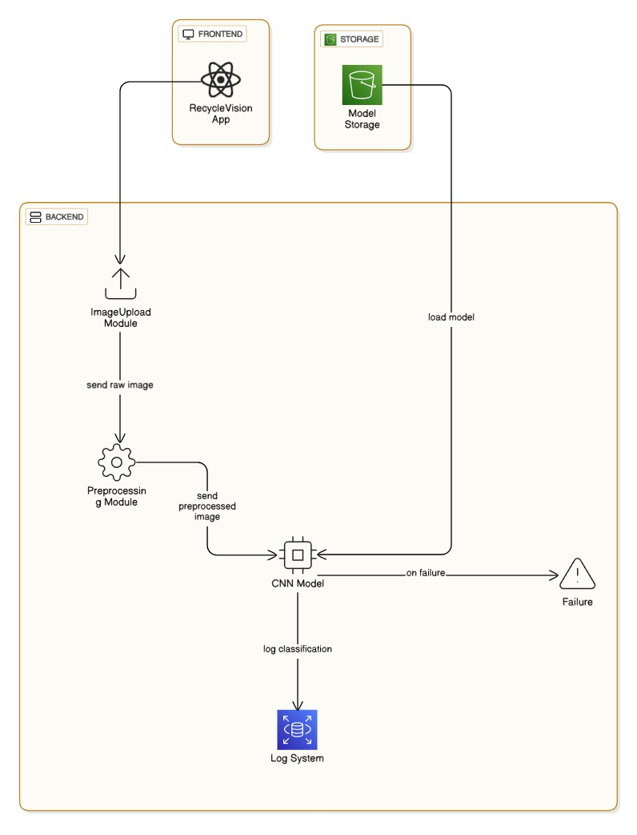

**5**

**4.2 UML DIAGRAMS**

**CLASS DIAGRAM**

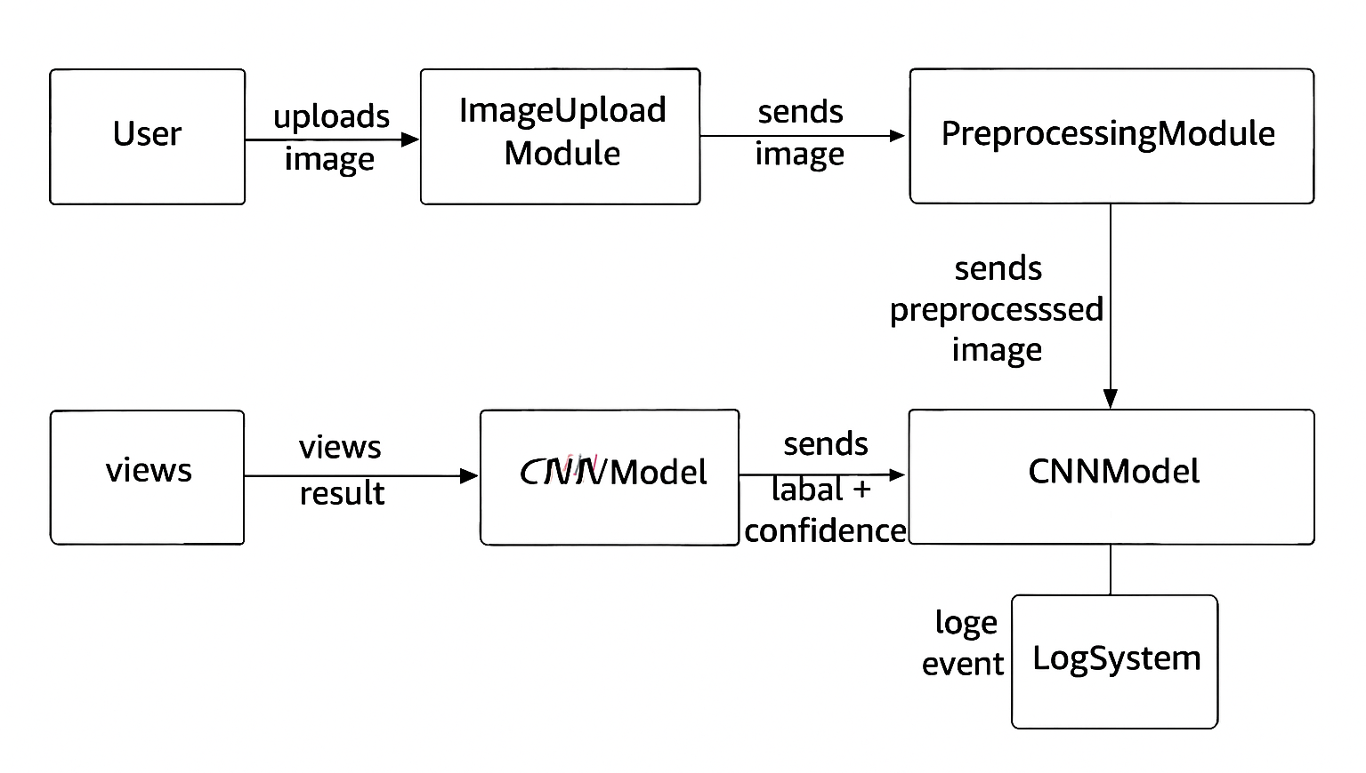

**SEQUENCE DIAGRAM**

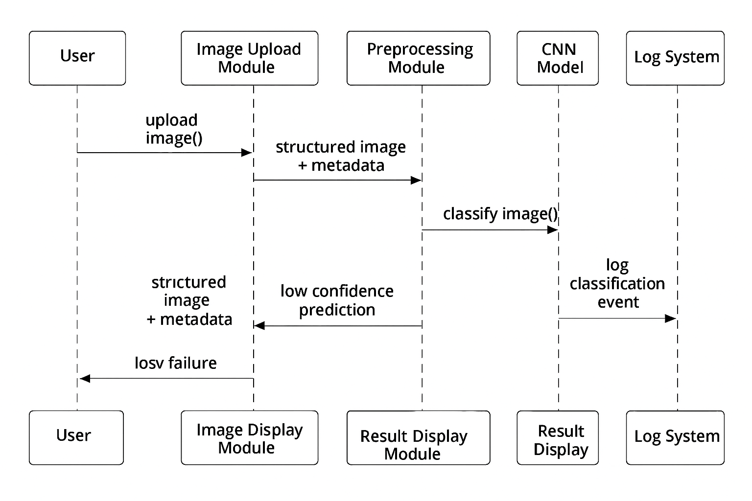

**6**

**ACTIVITY DIAGRAM**

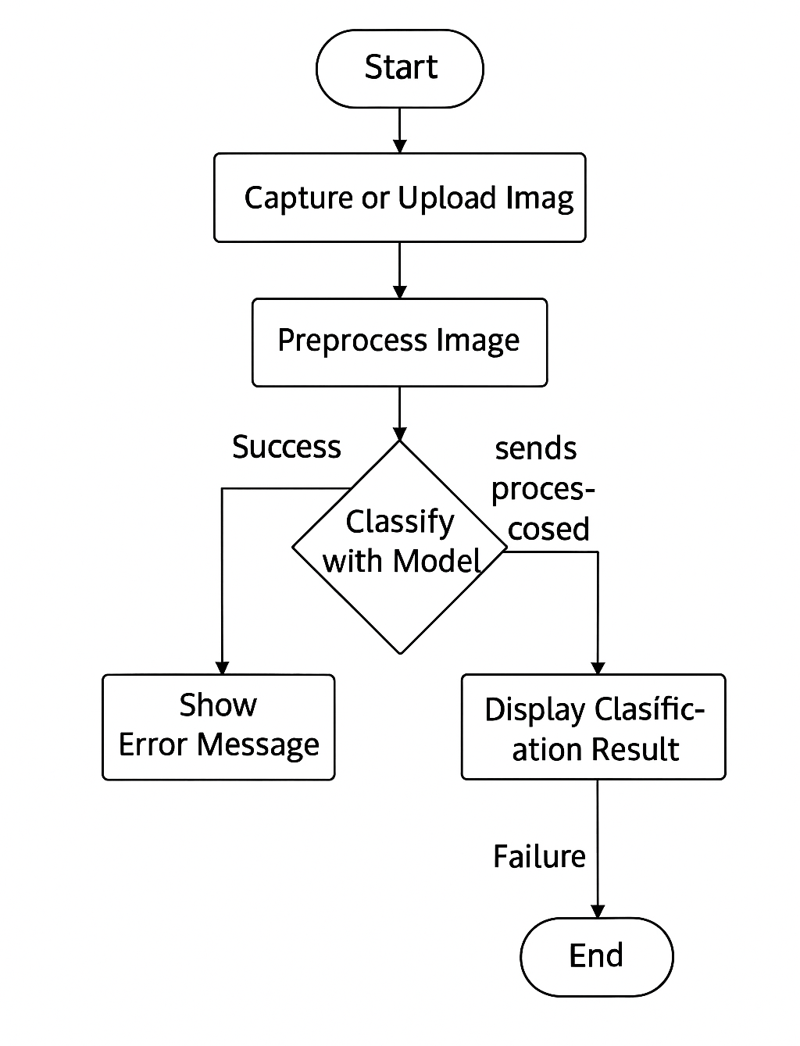

**7**

**METHODOLOGY**

**5.1 TECHNOLOGIES USED**

• **Python 3.10** : Primary programming language for developing the machine learning model and backend logic, chosen for its simplicity and extensive AI/data library support.

• **TensorFlow** : Open-source deep learning framework used to build and train CNN models for image classification.

• **Pandas** : Python library for data manipulation and analysis, helping with dataset handling and preprocessing tasks.

• **Supabase** : Cloud-based database platform for secure and efficient storage and management of image data and model results.

• **Convolutional Neural Networks (CNN)** : Deep learning algorithm for analyzing and classifying images by automatically detecting features.

• **Transfer Learning (ResNet, EfficientNet, YOLO)** : Pre-trained deep learning models leveraged to improve accuracy and reduce training time by reusing learned features.

• **Visual Studio Code (VS Code)** : Lightweight IDE used for writing, testing, and debugging Python code efficiently.

**5.2 ALGORITHMS / TECHNIQUES**

• **Convolutional Neural Networks (CNN):** Used for extracting features from images and classifying them into categories like plastic, metal, paper, etc.

• **Transfer Learning (ResNet, EfficientNet, YOLO):** Leveraging pre-trained models to reduce training time and improve accuracy.

• **YOLO (You Only Look Once):** Real-time object detection algorithm to detect and localize recyclable items in images.

• **Image Preprocessing:** Resizing, normalization, and augmentation (rotation, flipping, scaling) to improve model performance.

• **Feature Extraction:** Automatically extracting important visual features from images using CNN layers.

**8**

**IMPLEMENTATION**

**6.1 SAMPLE CODE**

INDEX PAGE :

<!DOCTYPE html>

<html lang="en">

<head>

<meta charset="UTF-8" />

<meta name="viewport" content="width=device-width, initial-scale=1.0" />

<title>RecycleVision - AI-Powered Recycling Guide</title>

<meta

name="description"

content="Transform the way you recycle with AI-powered waste identification. Upload an image and discover the best recycling practices for your items."

/>

<meta name="author" content="Srihari" />

<meta property="og:title" content="d728dfc1-8a55-42af-9b27-33ee42243cb9" />

<meta property="og:type" content="website" />

<link rel="icon" type="image/png" href="favicon.png" />

</head>

<body>

<div id="root"></div>

<script type="module" src="/src/main"></script>

</body>

</html>

CLASSIFICATION PAGE :

import { useState, useCallback } from "react";

import { Upload as UploadIcon, Camera, X, FileImage, Loader2 } from "lucide-react";

import { Card } from "@/components/ui/card";

import { Button } from "@/components/ui/button";

import { motion, AnimatePresence } from "framer-motion";

import { MotionButton } from "./MotionWrapper";

import { useNavigate } from "react-router-dom";

import { useToast } from "@/hooks/use-toast";

import { useClassification } from "@/contexts/ClassificationContext";

interface FileUploadProps {

onFileSelect: (file: File) => void;

}

**9**

const FileUpload = ({ onFileSelect }: FileUploadProps) => {

const [isDragOver, setIsDragOver] = useState(false);

const [showCamera, setShowCamera] = useState(false);

const [stream, setStream] = useState<MediaStream | null>(null);

const navigate = useNavigate();

const { toast } = useToast();

const { file, imageUrl, setFile, setResult, isLoading, setIsLoading, reset, uploadImage } = useClassification();const capturePhoto = () => {

const video = document.getElementById('camera-video') as HTMLVideoElement;

const canvas = document.createElement('canvas');

const context = canvas.getContext('2d');

if (video && context) {

canvas.width = video.videoWidth;

canvas.height = video.videoHeight;

context.drawImage(video, 0, 0);

canvas.toBlob((blob) => {

if (blob) {

const file = new File([blob], 'camera-capture.jpg', { type: 'image/jpeg' });

handleFileSelection(file);

stopCamera();

}

}, 'image/jpeg', 0.8);

}

};

const apiResponse = await fetch('https://api-inference.huggingface.co/models/prithivMLmods/Trash-Net', {

method: 'POST',

headers: {

'Authorization': Bearer ${import.meta.env.VITE_HUGGING_FACE_API_KEY},

'Content-Type': blob.type,

},

body: blob,

});

CONTACT PAGE :

import { Mail, MapPin, Phone, Github, Linkedin, Twitter } from "lucide-react";

import { Card, CardContent } from "@/components/ui/card";

import ContactForm from "@/components/ContactForm";

import { MotionWrapper, MotionCard } from "@/components/MotionWrapper";

import { Button } from "@/components/ui/button";

import { motion } from "framer-motion";

**10**

const Contact = () => {

const contactInfo = [

{

icon: Mail,

title: "Email Us",

details: "srihariyadav1343@gmail.com",

subtitle: "We'll respond within 24 hours"

},

{

icon: MapPin,

title: "Our Location",

details: "Maisammaguda, Bhadurpalle, Hyderabad, Telangana 500100",

subtitle: "Building a sustainable future"

},

{

icon: Phone,

title: "Call Us",

details: "+91 9515821175",

subtitle: "Mon-Fri, 9AM-6PM IST"

}

];

const socialLinks = [

{ icon: Github, href: "https://github.com/srihari-cpu", label: "GitHub", color: "hover:text-blue-600" },

{ icon: Linkedin, href: "https://www.linkedin.com/in/srihari1343/", label: "LinkedIn", color: "hover:text-blue-600" },

{ icon: Twitter, href: "https://x.com/srihari_c78032", label: "Twitter", color: "hover:text-blue-600" },

];

return (

<div className="min-h-screen">

{/* Modern gradient background */}

<div className="fixed inset-0 -z-10">

<div className="absolute inset-0 bg-gradient-to-br from-sky/20 via-background to-earth/20" />

<div className="absolute inset-0 bg-[radial-gradient(circle_at_30%_25%,hsl(var(--forest)/0.08),transparent_60%)]" />

<div className="absolute inset-0 bg-[radial-gradient(circle_at_70%_75%,hsl(var(--ocean)/0.08),transparent_60%)]" />

</div>

**11**

**6.2 OUTPUT SCREENS**

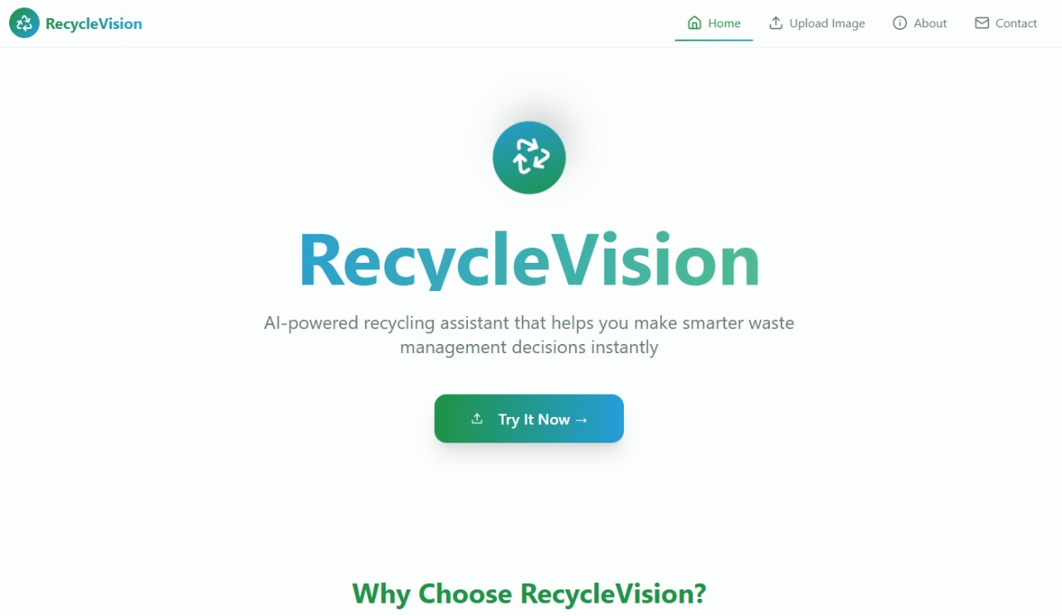

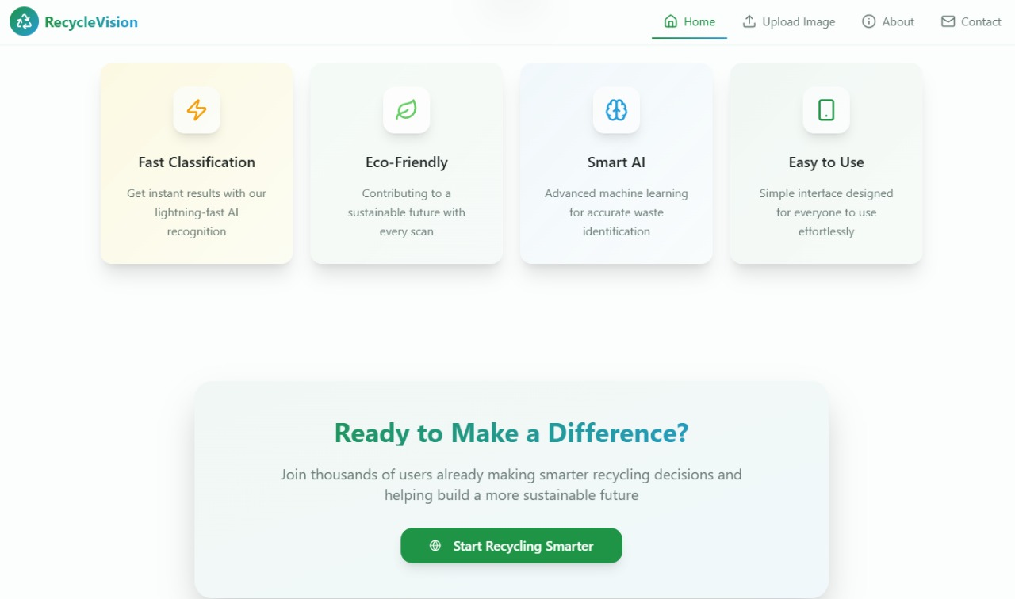

**12**

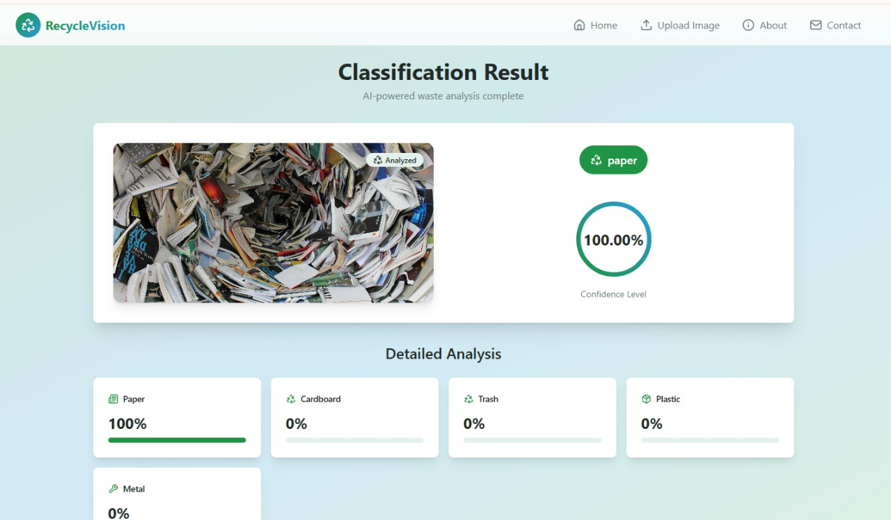

**13**

**TESTING**

**7.1 TESTING METHODS**

• **Train-Test Split:** Dividing the dataset into training and testing sets (commonly 80:20 or 70:30) to evaluate model performance on unseen data.

• **Cross-Validation:** Splitting the dataset into multiple folds and training/testing the model across them to ensure reliability and reduce overfitting.

• **Confusion Matrix:** Analyzing True Positives, True Negatives, False Positives, and False Negatives to assess classification performance.

• **Accuracy:** Measuring the percentage of correctly classified images out of the total images.

• **Real-Time Testing:** Using the trained model on new images or camera feed to test performance in practical scenarios.

• **Error Analysis:** Reviewing misclassified images to identify patterns or improvements for the model.

**7.2 TEST CASES**

• **Test Case 1 – Image Upload:** Verify that the system allows uploading images in supported formats (JPEG, PNG) without errors.

• **Test Case 2 – Image Preprocessing:** Check that uploaded images are resized, normalized, and augmented correctly before being fed to the model.

• **Test Case 3 – Image Classification:** Test that the model correctly classifies recyclable items (plastic, metal, paper, etc.) with expected accuracy.

• **Test Case 4 – Real-Time Detection:** Validate that YOLO or object detection works correctly on live images or camera feed.

• **Test Case 5 – Database Storage:** Ensure that classified images and results are stored correctly in the Supabase database.

• **Test Case 6 – Model Performance Metrics:** Verify that the system correctly calculates accuracy, precision, recall, and F1-score.

• **Test Case 7 – Error Handling:** Check how the system handles unsupported image formats or corrupted files.

**14**

**CONCLUSION**

This project helps to automatically identify different types of waste, like plastic, paper, glass, and metal, just by looking at pictures. It uses artificial intelligence to tell which items can be recycled, making waste sorting faster and easier. This saves time, reduces mistakes, and helps protect the environment. In the future, the system can be improved by adding more images and making it more accurate. It could also be used in real-life applications, like smart dustbins or mobile apps, to make recycling even easier for everyone. In the future, the system can be further enhanced by increasing the variety and number of training images, improving model accuracy, and incorporating real-time detection capabilities. These improvements would allow the technology to be integrated into practical applications, such as smart dustbins, mobile apps, or community recycling programs, making recycling more accessible and efficient on a larger scale.

**15**

**BIBILOGRAPHY**

<https://supabase.com/dashboard/project/ujhbvfuyakdtqbnjtxnx>

<https://huggingface.co/yangy50/garbage-classification?utm_source=chatgpt.com>

<https://github.com/srihari-cpu>

<https://www.nuclino.com/solutions/project-documentation>

[https://www.w3schools.com//php/default.asp](https://www.w3schools.com/php/default.asp)

**16**